**MODULE 9 ASSIGNMENT**

**PROBLEM 1**

**INITIAL DESIGN OF ERD**

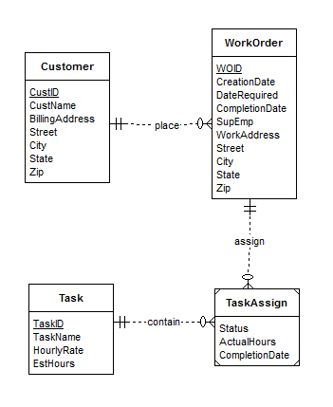

**REVISED ERD**

